 |  |  |  |  |  |  |   
  USN
Internal Assessment Test 2 - May 2026
Sub: |  | Machine Learning |  |  |  |  | Sub Code: | BCS602 | Branch: |  | ISE
Date: |  | 05/05/2025 | Duration: | 90 min | Max Marks: | 50 | Sem/Sec: | VI / A, B & C |  |  | OBE
Answer any FIVE FULL Questions |  |  |  |  |  |  |  |  |  | MARKS | CO | RBT
1a | Draw the simple perceptron model |  |  |  |  |  |  |  |  | [03] | CO4 | L1
1b | Diff between Reinforcement Learning and Supervised Learning |  |  |  |  |  |  |  |  | [07] | CO2 | L2
2a | List out the advantages of ANN |  |  |  |  |  |  |  |  | [02] | CO4 | L1
2b | Given the 5 weeks sales data for a shop in below table, apply linear regression technique to construct the best fit of line and predict 12th month sales |  |  |  |  |  |  |  |  | [05] | CO3 | L3
  x_{i} (week) | y_{i} (sales in thousands)
  1 | 1.2
  2 | 1.8
  3 | 2.6
  4 | 3.2
  5 | 3.8
2c | Explain Gibbs Algorithm |  |  |  |  |  |  |  |  | [03] | CO3 | L2
3a | Discuss ID3 Decision Tree algorithm in detail |  |  |  |  |  |  |  |  | [06] | CO3 | L3
3b | Explain Locally weighted regression |  |  |  |  |  |  |  |  | [04] | CO3 | L1
4 | Consider a perceptron to represent the Boolean function AND with the initial weigths w₁ = 0.3, w₂ = -0.2, learning rate α = 0.2, and bias ϴ = 0.4. Use Step function to calculate the output and derive the perceptron that performs AND operation. |  |  |  |  |  |  |  |  | [10] | CO4 | L3
5a | Advantages and Disadvantages of Clustering Algorithms |  |  |  |  |  |  |  |  | [03] | CO4 | L1
5b | Assess a student’s performance using Naïve Bayes algorithm with the dataset provided in the table. Apply Naïve Bayes theorem for this continuous attribute. |  |  |  |  |  |  |  |  | [07] | CO4 | L3
  S.No | CGPA | Interactiveness | Job Offer
  1. | 9.5 | Yes | Yes
  2. | 8.2 | No | Yes
  3. | 9.3 | No | No
  4. | 7.6 | No | No
  5. | 8.4 | Yes | Yes
6a | Consider the following set of data given in the table. Cluster it using k-means algorithm with the initial value of objects 2 and 5 with the coordinate values (4,6) and (12, 4) as initial seeds. |  |  |  |  |  |  |  |  | [05] | CO5 | L3
  Objects | X-Coordinate | Y - coordinate
  1 | 2 | 4
  2 | 4 | 6
  3 | 6 | 8
  4 | 10 | 4
  5 | 12 | 4
6b | If the given coordinates of the objects are (0,3) and (5.8), calculate the Euclidean, Manhattan and Chebyshev distance. |  |  |  |  |  |  |  |  | [03] | CO5 | L3
6c | Define SARSA learning |  |  |  |  |  |  |  |  | [02] | CO5 | L1

Answers
- A Draw the simple perceptron model
Explanation & Diagram:-1+2 marks
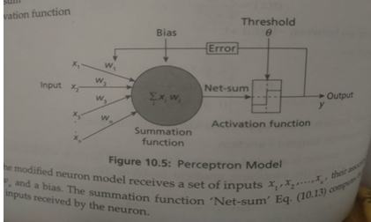

- B Diff between Reinforcement Learning and Supervised Learning
Difference:-1*7=7 Marks
Reinforcement Learning | Supervised Learning
No supervisor and labelled dataset initially | Presence of supervisor and labelled data
Decisions are dependent and are made sequentially | Decisions are independent of each other and based on input given in the training phase
Feedback is not instantaneous and delayed by time | Usually, the feedback is instantaneous once the model is created
Agent action affects the next input data | Dependent of initial input or the input given at start
No target values, only goal oriented | Target class is predefined by the problem
Example: Chess, GO, Atari Games | Example: Classifiers

2 a List out the advantages of ANN
Advantage:-1*2=2marks
ANNs can solve complex problems involving non-linear processes.
ANNs can learn and recognize complex patterns and solve problems as humans solve a problem.
ANNs have a parallel processing capability and can predict in less time.
They have an ability to work with inadequate knowledge. It can even handle incomplete and noisy data.
They can scale well to larger data sets and outperform other learning mechanisms.
2 b Given the 5 weeks sales data for a shop in below table, apply linear regression technique to construct the best fit of line and predict 12th month sales

Solution:- step by step: mean and average:- 02 Marks
Final Value :-03 Marks
x_{i} (week) | y_{i} (sales in thousands)
1 | 1.2
2 | 1.8
3 | 2.6
4 | 3.2
5 | 3.8
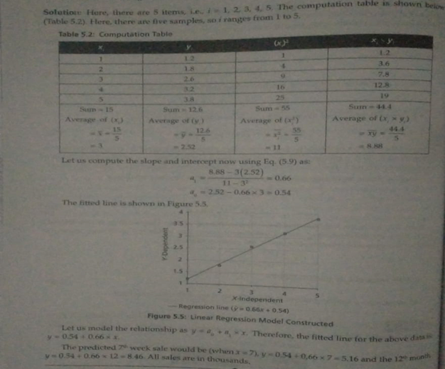
2 C Explain Gibbs Algorithm
Explanation:- 3 Marks
The main drawback of Bayes optimal classifier is that it computes the posterior probability for all hypotheses in the hypothesis space and then combines the predictions to classify a new instance.
Gibbs algorithm is a sampling technique which randomly selects a hypothesis from the hypothesis space according to the posterior probability distribution and classifies a new instance.
It is found that the prediction error occurs twice with the Gibbs algorithm when compared to Bayes optimal classifier.

3 a Discuss ID3 Decision Tree algorithm in detail
Explanation:-2 Marks
Algorithm:- 4 Marks
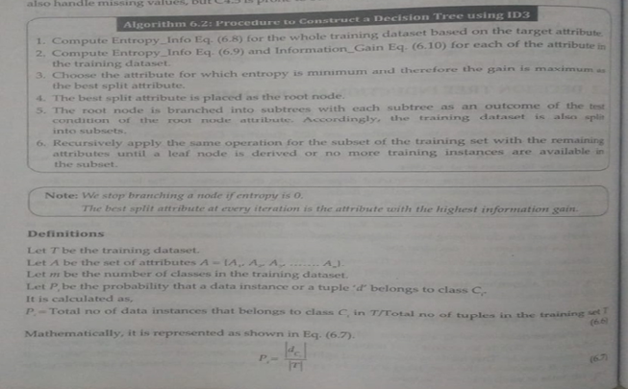
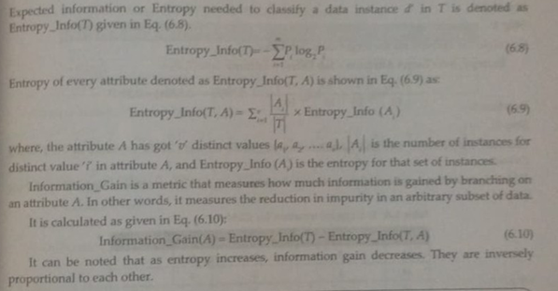
3 b Explain Locally weighted regression
Defination:- 2 Marks
Explanation:-4 Marks

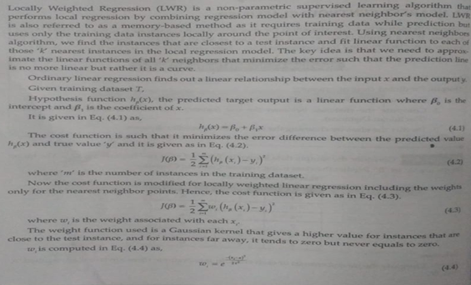
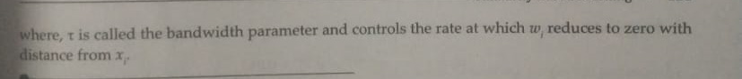
4 Consider a perceptron to represent the Boolean function AND with the initial weigths w₁ = 0.3, w₂ = -0.2, learning rate α = 0.2, and bias ϴ = 0.4. Use Step function to calculate the output and derive the perceptron that performs AND operation.
Stepby step solve:- 10 Marks
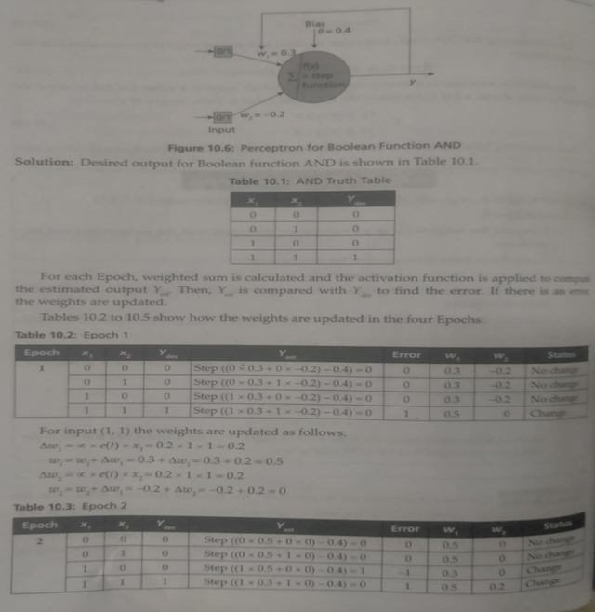
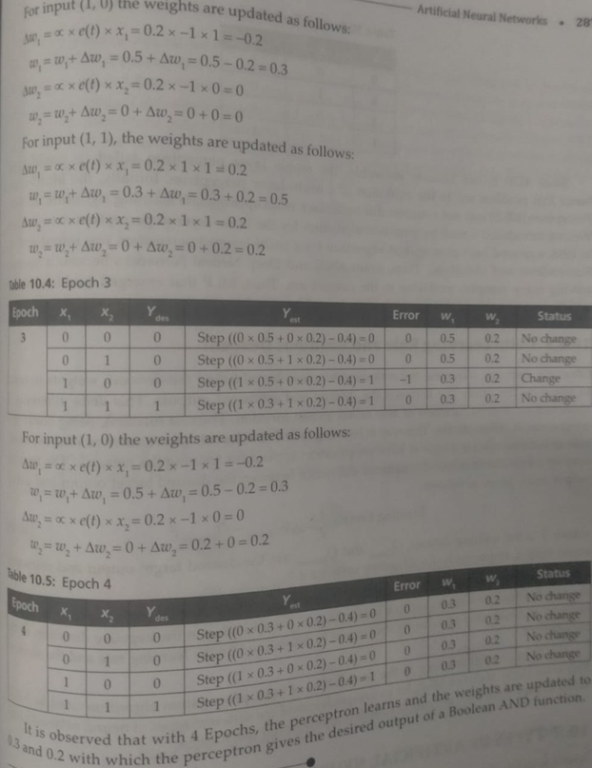

5 a Advantages and Disadvantages of Clustering Algorithms
Difference:- 1*3= 3 Marks
S.No. |  | Advantages | Disadvantages
1 |  | Cluster analysis algorithms can handle missing data and outliers. | Cluster analysis algorithms are sensitive to initialization and order of the input data.
2 |  | Can help classifiers in labelling the unlabeled data. Semi-supervised algorithms use cluster analysis algorithms to label the unlabeled data and then use classifiers to classify them. | Often, the number of clusters present in the data have to be specified by the user.
3 | It is easy to explain the cluster analysis algorithms and to implement them. |  | Scaling is a problem.
4 | Clustering is the oldest technique in statistics and it is easy to explain. It is also relatively easy to implement. |  | Designing a proximity measure for the given data is an issue.
5 b Assess a student’s performance using Naïve Bayes algorithm with the dataset provided in the table. Apply Naïve Bayes theorem for this continuous attribute.
Solve step by step:- 7 Marks

S.No | CGPA | Interactiveness | Job Offer
1. | 9.5 | Yes | Yes
2. | 8.2 | No | Yes
3. | 9.3 | No | No
4. | 7.6 | No | No
5. | 8.4 | Yes | Yes
Step 1: Compute the prior probability for the target feature ‘Job Offer’
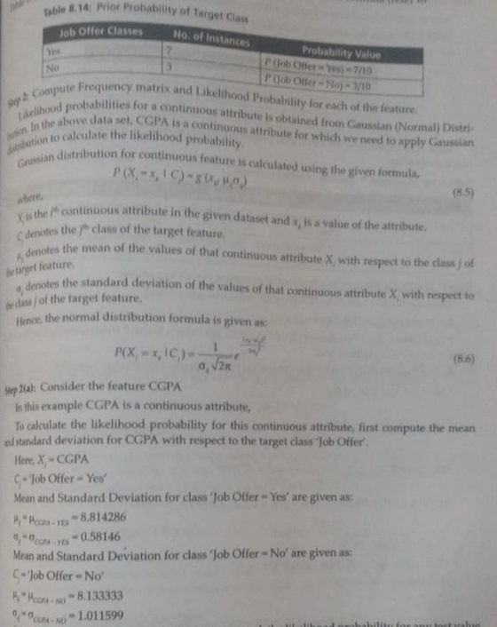
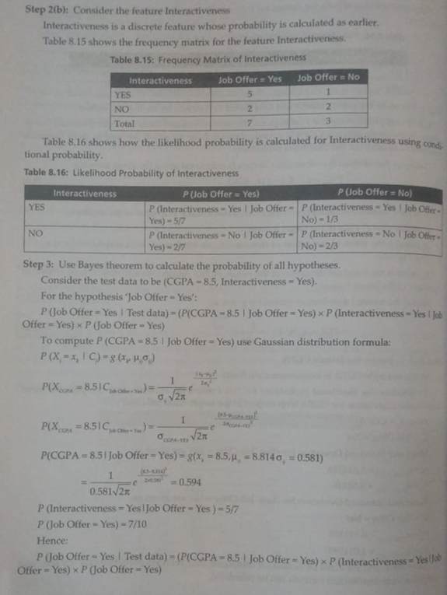
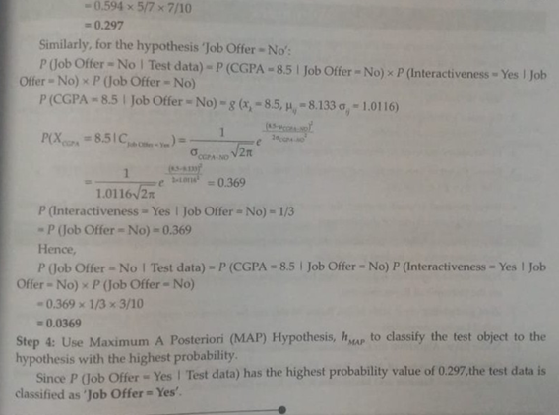
6 a Consider the following set of data given in the table. Cluster it using k-means algorithm with the initial value of objects 2 and 5 with the coordinate values (4,6) and (12, 4) as initial seeds.

Objects | X-Coordinate | Y - coordinate
1 | 2 | 4
2 | 4 | 6
3 | 6 | 8
4 | 10 | 4
5 | 12 | 4

Solution step by step:- 5 Marks
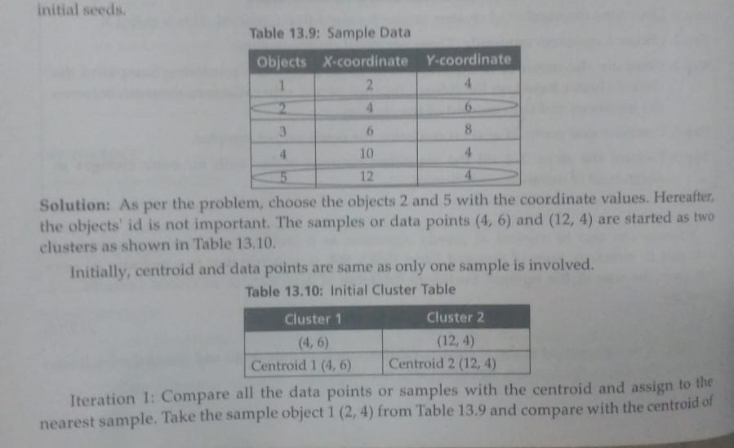
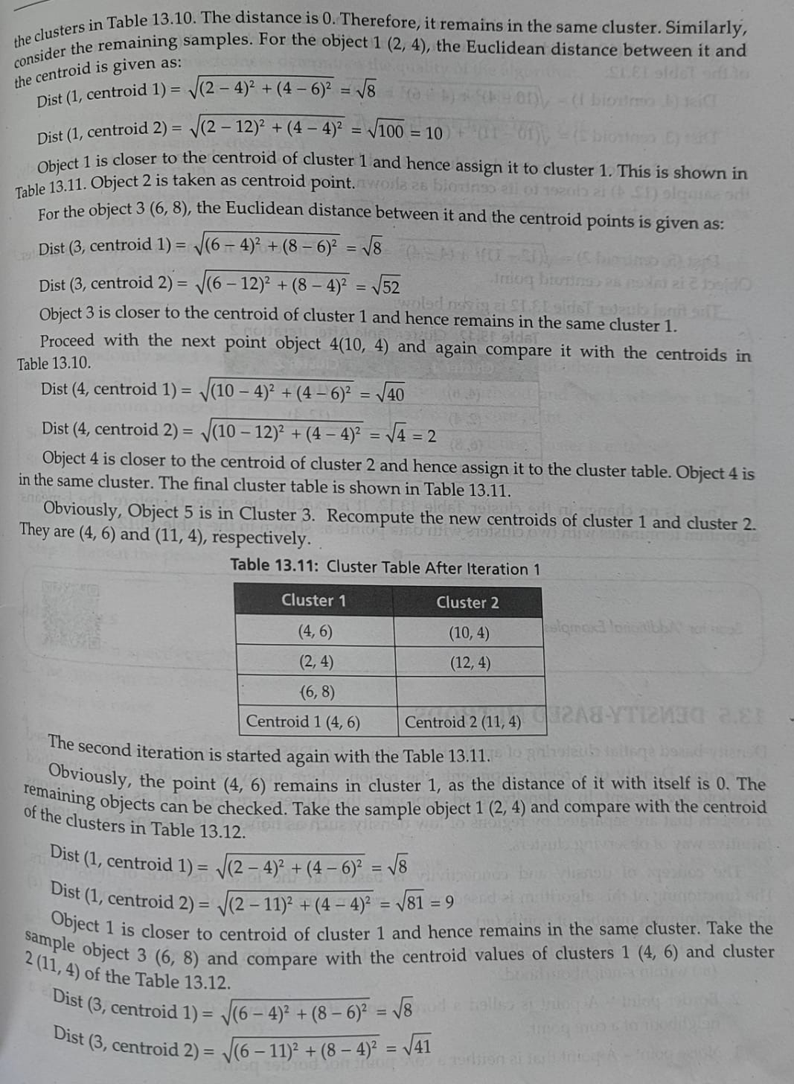

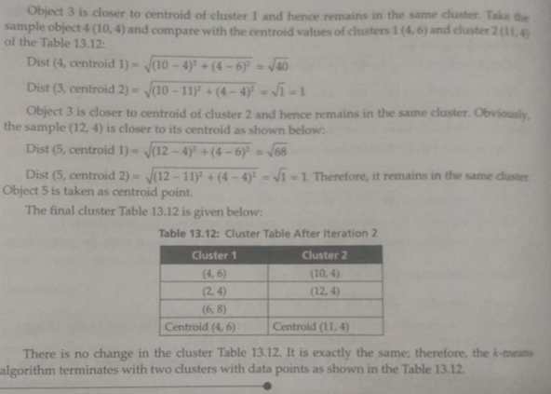
6 b If the given coordinates of the objects are (0,3) and (5.8), calculate the Euclidean, Manhattan and Chebyshev distance.
Formula:- 2 Marks
Calculation:-1 Marks
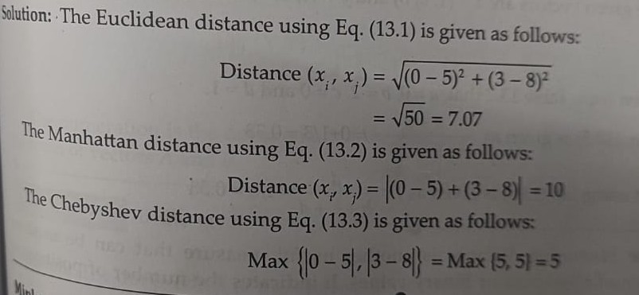
6 c Define SARSA learning
Definition:- 1 Marks
Explanation:-1 Marks
